QUESTION PAPER GENERATOR

A SYNOPSIS REPORT ON

Submitted in Partial fulfillment for the award of Degree of Bachelor of Engineering in Computer Science &Engineering

Submitted to
RAJIV GANDHI PROUDYOGIKI VISHWAVIDYALAYA BHOPAL (M.P)



MAJOR PROJECT REPORT

Submitted by

Sumit Sahu [0157CS181166]

Under the supervision of
HOD:-Dr. Ashish Khare Sir




DEPARTMENT OF COMPUTER SCIENCE& ENGINEERING

LAKSHMI NARAIN COLLEGE OF TECHNOLOGY &SCIENCE BHOPAL (M.P.)
DEPARTMENT OF COMPUTER SCIENCE& ENGINEERING



Certificate

This is to certify that the work embodied in this report entitled “QUESTION PAPER GENERATOR” has been satisfactorily completed by Sumit Sahu (0157CS181166) , of third year .It is bonafied piece of work carried out under guidance in the department of Computer Science & Engineering, Lakshmi Narain College of Technology & Science, Bhopal (M.P.). for partial fulfillment of the Bachelor of Engineering Degree in Computer Science & Engineering, during the academic year 2020-21
Under the Guidance of
---------------------------
Project guide
Approved by
Dr. Ashish Khare
Head of the Department
Forwarded by
Dr. A.K. Sachan
Principal

LAKSHMI NARAIN COLLEGE OF TECHNOLOGY &SCIENCE BHOPAL (M.P.)
DEPARTMENT OF COMPUTER SCIENCE& ENGINEERING

CERTIFICATE OF APPROVAL

This foregoing project work is hereby approved as a creditable study of Engineering carried out and presented in a manner satisfactory to warranty its acceptance as a prerequisite to the degree for which it has been submitted. It is understood that by this approval the undersigned do not necessarily endorse or approve any statement made, opinion expressed or conclusion drawn there in, but approve the project only for the purpose for which it has been submitted.

Internal Examiner External Examiner
Date:

LAKSHMI NARAIN COLLEGE OF TECHNOLOGY &SCIENCE BHOPAL (M.P.)
DEPARTMENT OF COMPUTER SCIENCE& ENGINEERING

DECLARATION

We, Sumit Sahu (0157CS181165), student of “Bachelor of Engineering in Computer science & engineering”, session: 2020-21, Lakshmi Narain College of Technology & Science Bhopal (M.P.), hereby declare that the work presented in this project entitled “LOAN COLLECTION AND RECOVERY SERVICES” is the outcome of our own work, is bonafide and correct to the best of our knowledge and this work has been carried out taking care of Engineering Ethics. The work presented does not infringe any patented work and has not been submitted to any other University or anywhere else for the award of any degree or any professional diploma.

………………………..

Sumit Sahu

(015CS181166)

Bhopal:
Date:

LAKSHMI NARAIN COLLEGE OF TECHNOLOGY &SCIENCE BHOPAL (M.P.)
DEPARTMENT OF COMPUTER SCIENCE& ENGINEERING

ACKNOWLEDGEMENT

The satisfaction that accompanies that the successful completion of any task would be incomplete without the mention of people whose ceaseless cooperation made it possible, whose constant guidance and encouragement crown all efforts with success.

We give all honor and praise to GOD ALMIGHTY who gave as wisdom and guided us during the entire course of our project.
We express our heartfelt gratitude towards Dr. A.K. Sachan, Principal Lakshmi Narain College of Technology & science Bhopal (M.P.), for granting us permission to work on this project.

We wish to place on record our sincere thanks to our head of the department Dr. Ashish Khare and project coordinators ------------------ for their thoughtful comments and help.

We also express our gratitude and thanks to our staff tutors and all other faculty members of the department of Computer Science and Engineering, Lakshmi Narain college of Technology & science Bhopal (M.P.), for their quick help and expert opinions for completing this project.

TABLE OF CONTENTS

CHAPTER | CONTENTS | PAGE NO
 | Abstract | 1
1 | Introduction | 2
2 | Review of Literature | 3
3 | Objective of Proposed Study | 4-5
4 | SDLC Model | 6-11
5 | Methodology | 12
5.1 | Types Of Research | 12
5.2 | Collection Of Data | 12
5.2.1 | Primary Data | 12
5.2.2 | Secondary Data | 12
5.3 | Sampling Unit | 12
5.4 | Sampling Size | 12
5.5 | Data Analysis and Interpretation | 13
6 | Scope Or Relevance Of Proposed Study | 14-15
7 | References | 16-17

ABSTRACT

Information and intelligence are two vital columns on which development of humankind rise and knowledge has significant impact on operating of society. Student assessment is a crucial part of teaching and is done through the process of examinations and preparation of exam question papers has consistently been a matter of interest. Present-day technologies assist the teacher to stock the questions in a computer databases but the problem which emerges is how the present day technologies would also assist the teachers to automatically create the variety of questions from every now and then without worry about replication and duplication from the previous exam while the question bank keeps growing.

A non-automatic path for conniving a exam paper would not be able to serve to this need so in this paper we introduce an way which would permit the operation of conniving exam paper to be further well organized and productive and Hence there appears a requirement to have a system which will automatically create the question paper from teacher entered description within few seconds. In this paper we have implemented a modern evolutionary path that is able to manage multi-constraints issue along with creating question papers for examinations in autonomous institutes from a very vast question bank database. The endeavor needed for generating question paper is diminished after the implementation of this advanced system and because of this advanced system there is no obligation for humans to ponder and employ time which can be utilized on some additional important duty instead of designing question paper.

The project automatic question paper generation system will enable college authorities to automatically generate question papers out of existing question bank in the database.The paper generator is the one & only software for setting examination question paper. Software is very useful for small medium and large scale institutes. The software will use the database to harness the question paper where the database could consist thousands of questions. The software will empower the college with a powerful tool to generate question papers in a very short span of time thus saving a lot of their precious time. Keywords: automatic, paper, question, generator, SQL, Microsoft SQL, AQPG, exam

The objective of this project is to manage the details of students, examinations, marks, courses and papers in a good manner. The performance of the application will be fully control by administrator and administrator can guaranty any one to access. The project will reduce the manual process in managing examinations and all issues regarding that.

CHAPTER 1
INTRODUCTION

The ‘QUESTION PAPER GENERATOR’ project will be developed to overcome the time consuming problem of manual system. Apart from that in current system, checking the answer sheets after taking test, waste the examiners time, so this application will check the correct answer and save the examiner time and carry the examination in an effective manner. The users which are use this system don’t need to high computing knowledge and also system will inform them while entering invalid data.

The aim of this project is to computerized the existing manual system and help the examiners to save their valuable time and important data. Apart from this, data which are exist in this system, will exist for long period of time and will be easy accessible. This project helps the examiners to manage their services in a good way and provide a better service to their users.

The objective of this project is to manage the details of students, examinations, marks and papers in a good manner. The performance of the application will be fully control by administrator and administrator can guaranty any one to access. The project will reduce the manual process in managing examinations and all issues regarding that.

Existing Systems:

In this QUESTION PAPER GENERATOR quiz application which is designed and implemented in NetBeans based we try to overcome the existing problems with following features:

Remove source confuse issue;
Better management;
Connection to database for better storing of data;
Better frontend management;
Better backend management;

It’s very much different from other paper generation systems. It utilizes the power of Microsoft SQL to generate the paper. The questions are stored in the database and new questions can be added later on if needed. This system is so powerful that we can generate one question paper in just one second. Its primary characteristics is the automation of process of creation of question paper which reduces human effort to very far extent. Although it’s most prevalent use is within the universities to generate the question paper.

CHAPTER 2
REVIEW OF LITERATURE

Question Paper Generation has been a field of interest for many researchers and a lot of research has been done for question paper generation system. Researchers are very much interested in this field and they are showing their interest too. The reason behind the interest is basically the time consumed in generating the paper by the professors. And every researcher has undergone the university processes.

The paper presented by Mr. MihirJoisher, Mr. SwapnilGhagare, Ms. Mittal Patel and Mr. RiteshRathi describes a shuffling algorithm which randomizes the questions from the database.
Their algorithm is straight forward and easy to understand and implement in other systems too.

The paper presented by SurajKamya, MadhuriSachdeva, NavdeepDhaliwa and Sonit Singh proposed a system based on Fuzzy Logic in which all parameters where categorized based upon some logic so that the system can be easily acquainted with them.

Drawback of this system was that it could only provide results on the basis of analytical and descriptive format; it could not provide Multiple Choice Questions. The paper presented by Vijay KrishanPurohit', Abhijeet Kumar', AsmaJabeen, Saurabh Srivastava, R H Goudar ,Shivanagowda proposed a system “Design of Adaptive Question Bank Development and Management System” that was an adaptive system but the data entered is assumed to be error free which could affect the overall accuracy of the system.

The paper presented by Noor Hasimah Ibrahim Teo, Nordin Abu Bakar, MohamadRezduanAbd Rashid proposed a system “Representing Examination Question Knowledge into Genetic Algorithm” in which text matching and question sorting was done by the system itself but one of the major limitations of this system was the total number of questions that could be added

The outcome of coaching and education can be attained by performing evaluation to compute student’s intellectual levels and therefore the written exam is a method for teachers to validate student understanding and knowledge, as well as, to evaluate the degree to which students are able to adjust a learning this in a given environment.Therefore, the question must be catering in following with the subject contents learned by students to attain learning outcomes. However, the technique of questions writing is very demanding task for the teacher.

CHAPTER 3
OBJECTIVE OF PROPOSED STUDY

Project Objectives:

The main objective of the project QUESTION PAPER GENERATOR Quiz Application is to manage the details of students, examinations, marks and papers. The project is totally at administrative end and thus only the administrator is granted the access. The purpose of the project is to build an application to reduce the manual work for managing the project QUESTION PAPER GENERATOR Quiz and we will follow to achieve these objectives in this project.

To create an appropriate platform for best managing of MCQ test;
To overcome the time consuming issues and taking MCQ tests;
To release the marks of the test taker as soon as possible;
To manage the information of different tests.

The "Automatic Question Paper Generator" has been developed to override the problems prevailing in the practicing manual system. This software is supported to eliminate and, in some cases, reduce the hardships faced by this existing system. Moreover, this system is designed for the particular need of the company to carry out operations in a smooth and effective manner.

Conventional exam paper generation systems followed by institutes have many flaws such as repeated questions in the paper and time requirements. To overcome them we are proposing a new system. Automatic Question Paper Generator is a software which is beneficial to colleges, publishers, and test paper setters who want to possess an enormous database of questions and generate test papers frequently with ease. It mainly deals with the sorting, gathering and administration of an outsized amount of questions on different levels of toughness from scientific and also non-scientific subjects associated with various classes. There are two modules in this software: A. Admin Module B. User Module

The proposed online exam system has following objectives,
• Generates the Question Paper in a matter of seconds.
• Reduce the staff efforts.
• To guide the student for wrong answers in demo test.
• Display the result of examination immediately after exam is over.
• To increase the performance of the student

CHAPTER 4
SDLC MODEL OF THE PROJECT

Software Development Life Cycle(SDLC):- One of the basic notions of the software development process is SDLC models which stands for Software Development Life Cycle models. SDLC – is a continuous process, which starts from the moment, when it’s made a decision to launch the project, and it ends at the moment of its full remove from the exploitation. There is no one single SDLC model. They are divided into main groups, each with its features and weaknesses.

Evolving from the first and oldest “waterfall” SDLC model, their variety significantly expanded. The SDLC models diversity is predetermined by the wide number of product types – starting with a web application development to a complex medical software. And if you take one of the SDLC models mentioned below as the basis – in any case, it should be adjusted to the features of the product, project, and company. The most used, popular and important SDLC models are given below:

Waterfall model
Iterative model
Spiral model
V-shaped model
Agile model

No matter what type of the models has been chosen, each of them has basic stages which are used by every software development company. Let’s explore those stages as this is important for the understanding of the each of SDLC models and the differences between them.

BASIC STAGES OF SOFTWARE DEVELOPMENT LIFE CYCLE

Stage 1. Planning and requirement analysis

Each software development life cycle model starts with the analysis, in which the stakeholders of the process discuss the requirements for the final product. The goal of this stage is the detailed definition of the system requirements. Besides, it is needed to make sure that all the process participants have clearly understood the tasks and how every requirement is going to be implemented. Often, the discussion involves the QA specialists who can interfere the process with additions even during the development stage if it is necessary.

Stage 2. Designing project architecture

At the second phase of the software development life cycle, the developers are actually designing the architecture. All the different technical questions that may appear on this stage are discussed by all the stakeholders, including the customer. Also, here are defined the technologies used in the project, team load, limitations, time frames, and budget. The most appropriate project decisions are made according to the defined requirements.

Stage 3. Development and programming

After the requirements approved, the process goes to the next stage – actual development. Programmers start here with the source code writing while keeping in mind previously defined requirements. The system administrators adjust the software environment, front-end programmers develop the user interface of the program and the logics for its interaction with the server.
The programming by itself assumes four stages
Algorithm development
Source code writing
Compilation
Testing and debugging

Stage 4. Testing

The testing phase includes the debugging process. All the code flaws missed during the development are detected here, documented, and passed back to the developers to fix. The testing process repeats until all the critical issues are removed and software workflow is stable.

Stage 5. Deployment

When the program is finalized and has no critical issues – it is time to launch it for the end users. After the new program version release, the tech support team joins. This department provides user feedback; consult and support users during the time of exploitation. Moreover, the update of selected components is included in this phase, to make sure, that the software is up-to-date and is invulnerable to a security breach.

CHAPTER 5 METHODOLOGY

The methodology of developing of project will be a step-by-step sequence to design, develop and deliver the application. In software engineering this methodology called ‘waterfall model’ which one portion of work follows after another in a linear sequence. Following steps will be followed in this methodology:

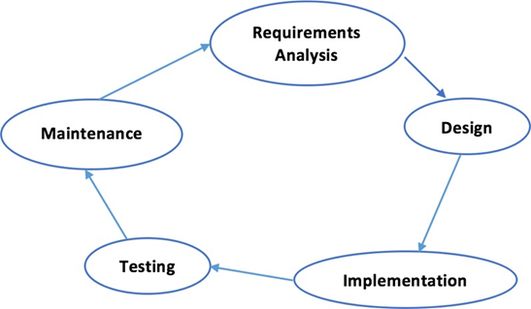

- Initiation (Requirement Specification);
- Planning and design;
- Execution (construction and coding);
- Validation (Testing);
- Closure (Installation and Maintenance).

Flow Chart Diagram:

- Admin Log-In:

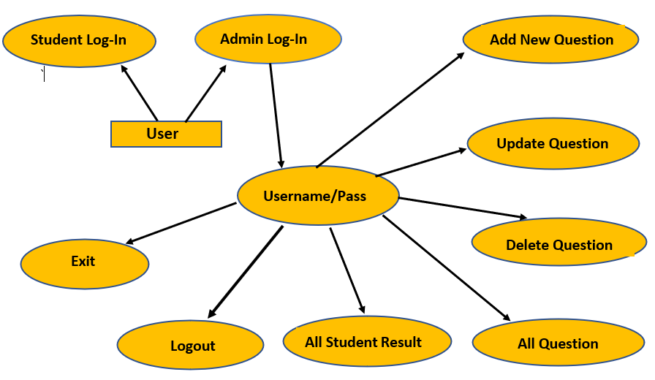

- Student Log-In:
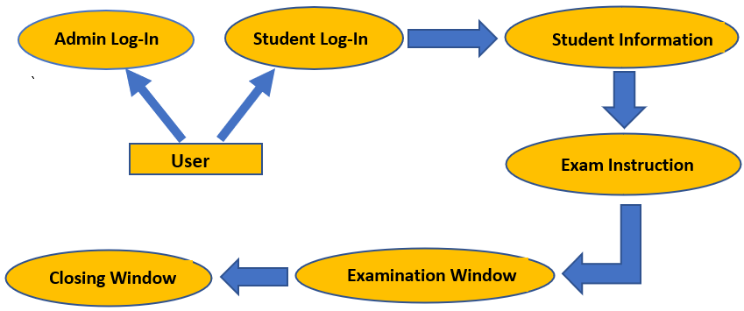
CHAPTER 6
SCOPE OR RELEVANCE OF PROPOSED STUDY

As mentioned the project is on java platform which is coded in NetBeans IDE and running an application by HeidiSQL for Database. But this project is only for MCQ test but in the future we have plan to extended it to support randomness of the questions with more functionality.

By project requirements specifications we can analyze the tasks which going to be done by the system. The function and performance of allocated to software as part of system engineering are refined by establishing a complete information description. A detailed functional and behavioral description of the project and concentrating on requirements and constraints of that will provide and good product. The proposed system should follow these requirements:

System must store information about users (Student and Teachers), tests, questions and result;
System should able the teacher to punch tests;

Each teacher should be able to punch many tests;
System should do not allow unauthorized user to enter the system;
Each student should be able to attempt many tests;
System should keep and display the results of Students;
System should support test which one or more question dependent on it;
System should allow the administrator to delete and update tests and questions dependent on it.

Question Paper Generator is designed keeping in mind with many future possibilities that can improve the software to be more productive and secure. [2] These include:

- The methodologies that we presented for generating question paper show promising outcomes and can be utilized as a basis for making a more advanced automatic and independent paper generator.
- This software can take its true form when a large number of questions are added into a dedicated database which will unlock a whole new potential of portability.
- With the large database security threats are a major concern. To avoid this, a more secure database can also be achieved, which will make sure that only an authorized person can have access to this software.
- Our effort is to develop this software for important exams such as SSC, HSC. This will be beneficial to the students as they are more inclined to solve multiple papers.
- With all these possibilities, this software will be more secure and will also provide much better results.
Project Design:

For designing and implementing of Desktop Question Paper Generator Quiz application we used Java Swing, AWT, and SQL Server with the context of Java.

Index Page:

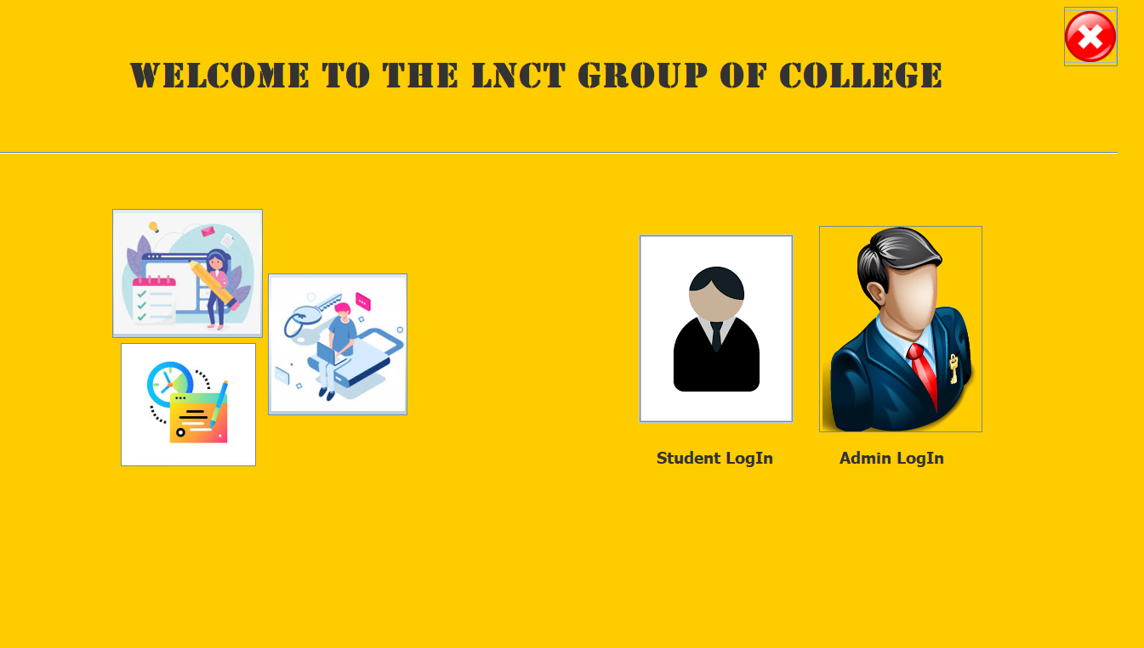

Login Page:

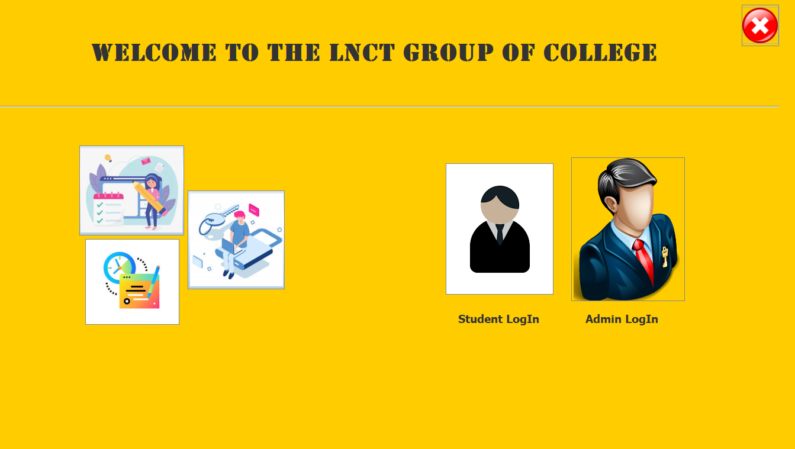

Admin Username/Password Verify:

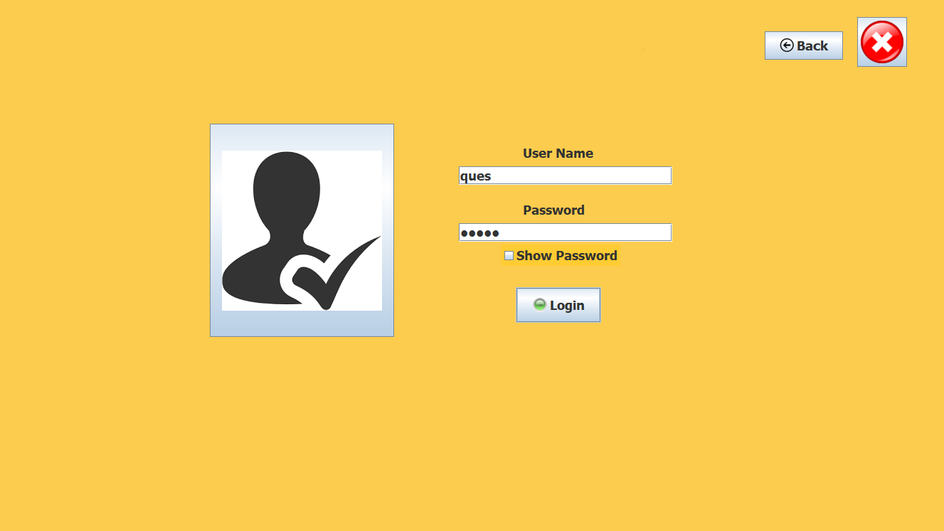

Home Pages:

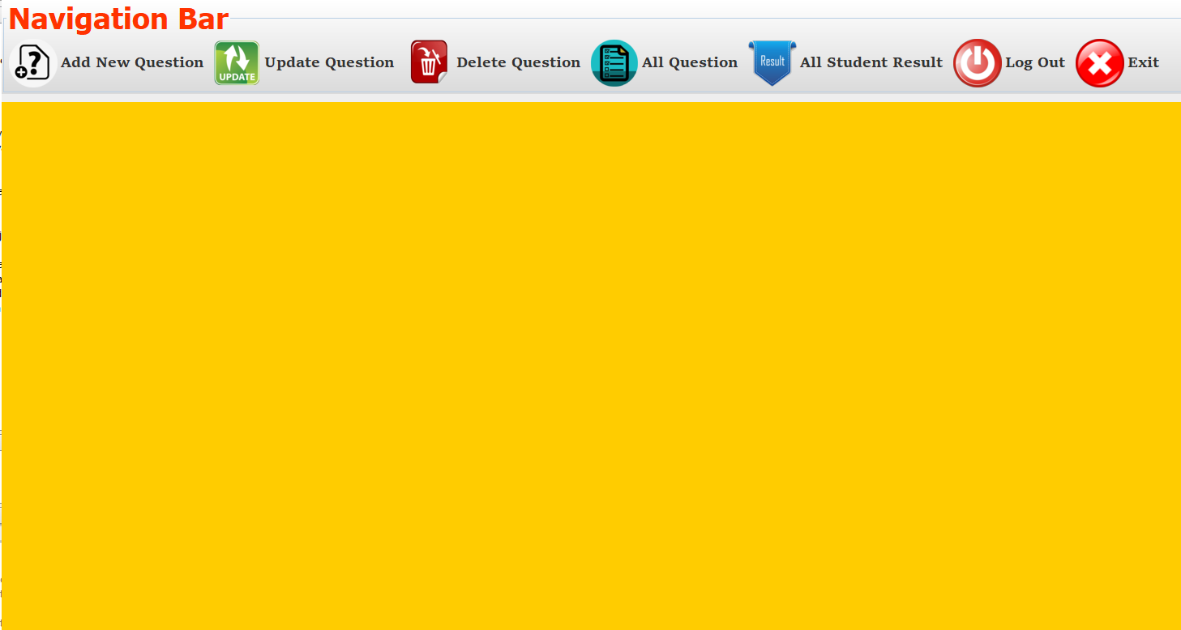

Add New Question:

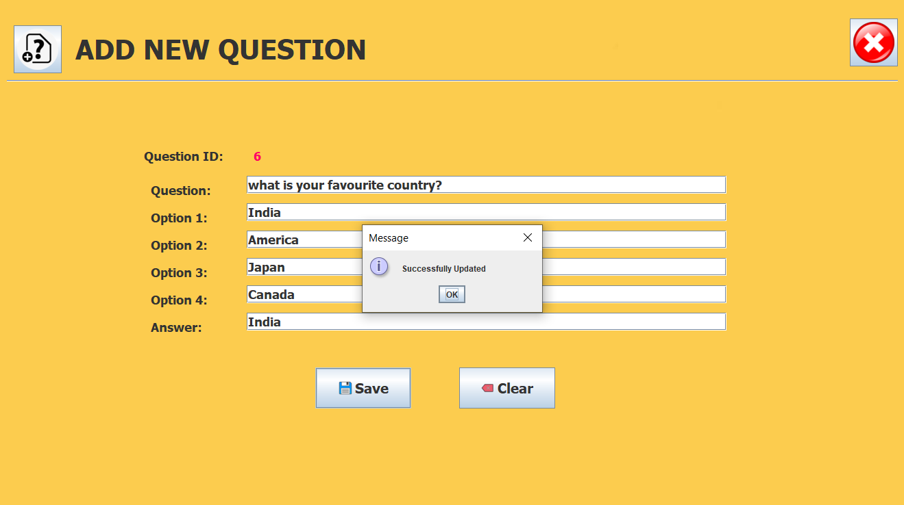

Update Question:

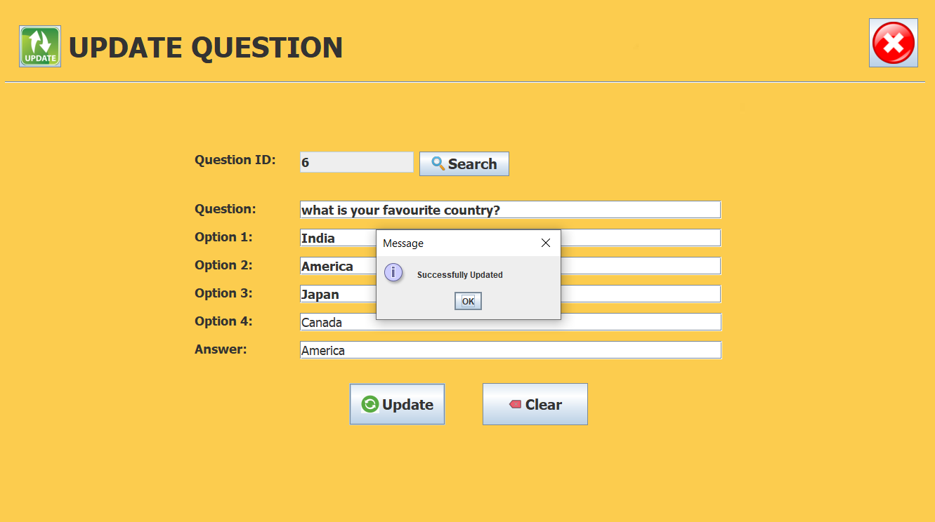

Delete Question:

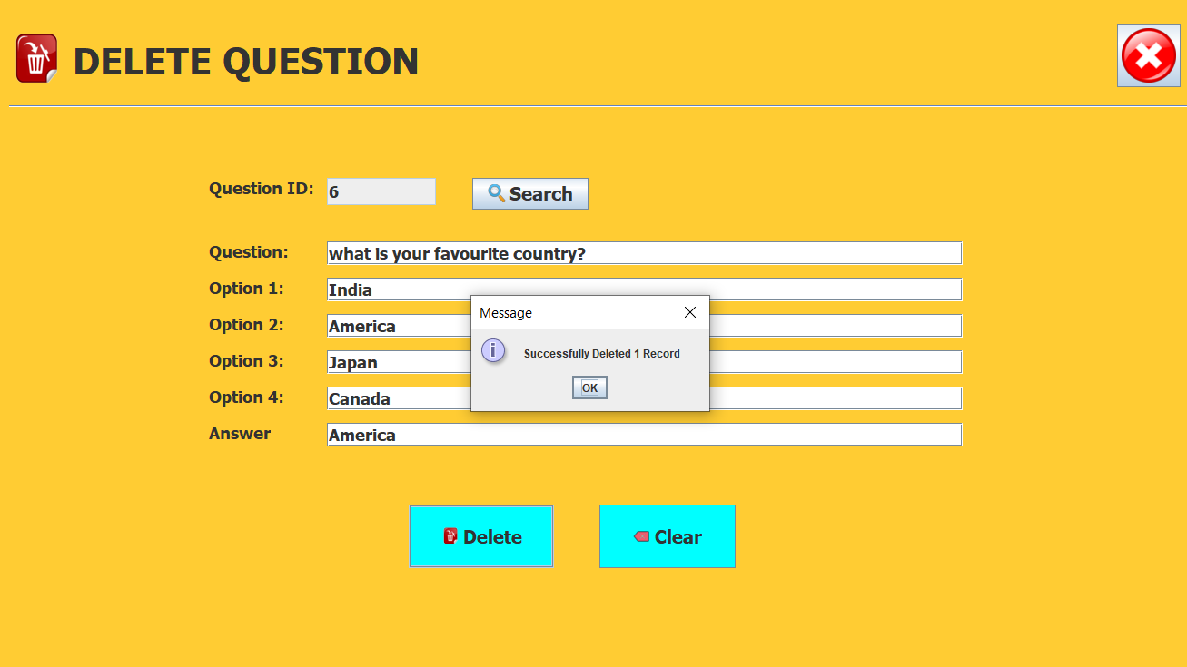

All Question:

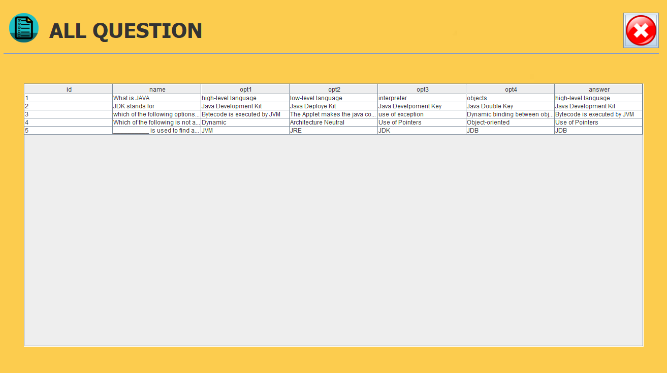

All Student Result:

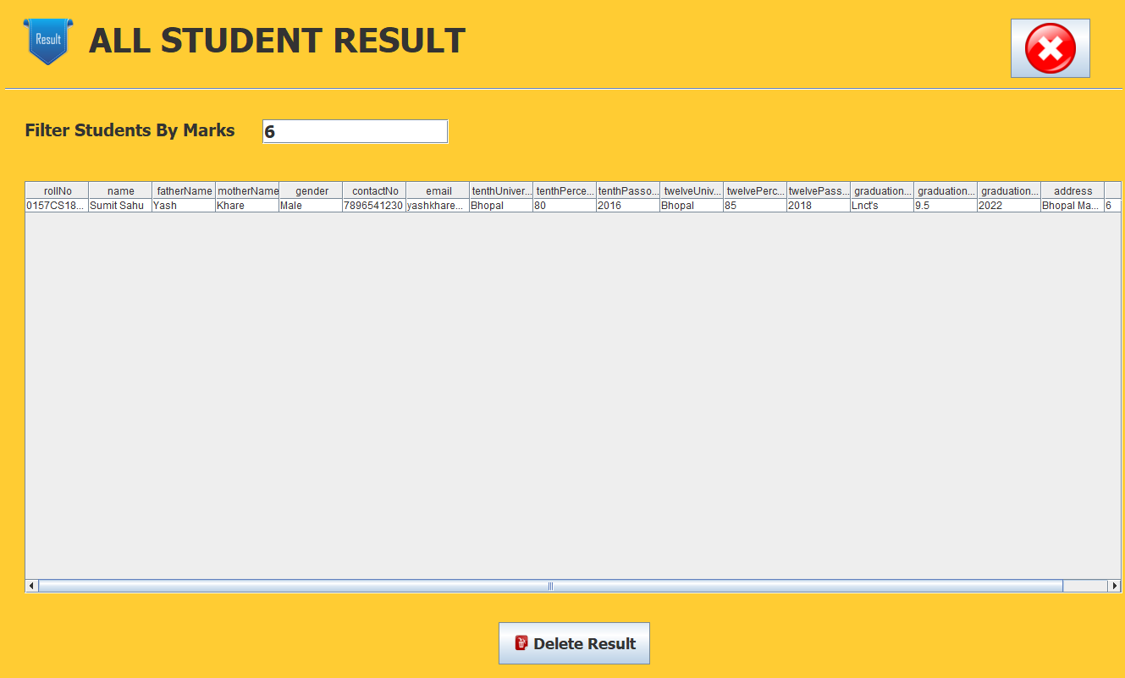
Delete Result:

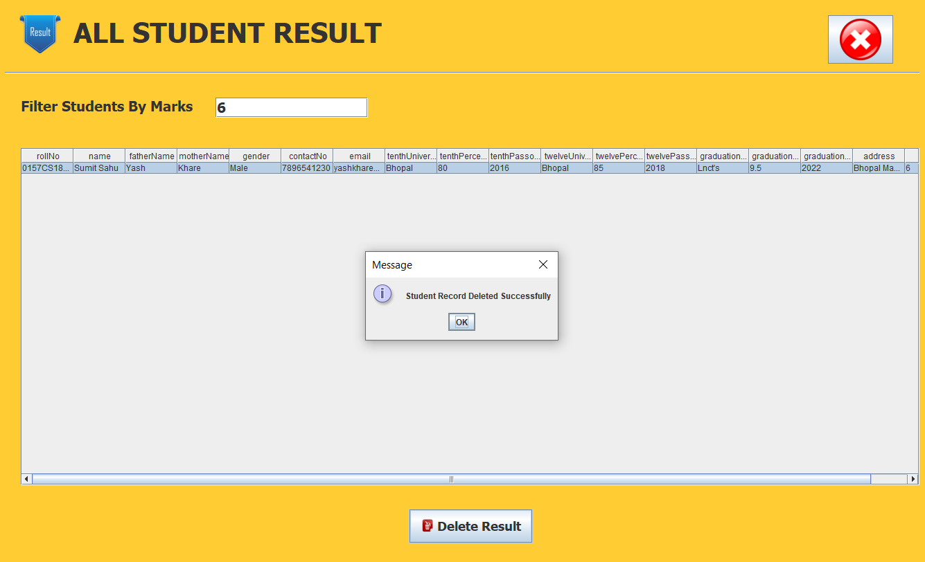

Student Login:

Student Info:

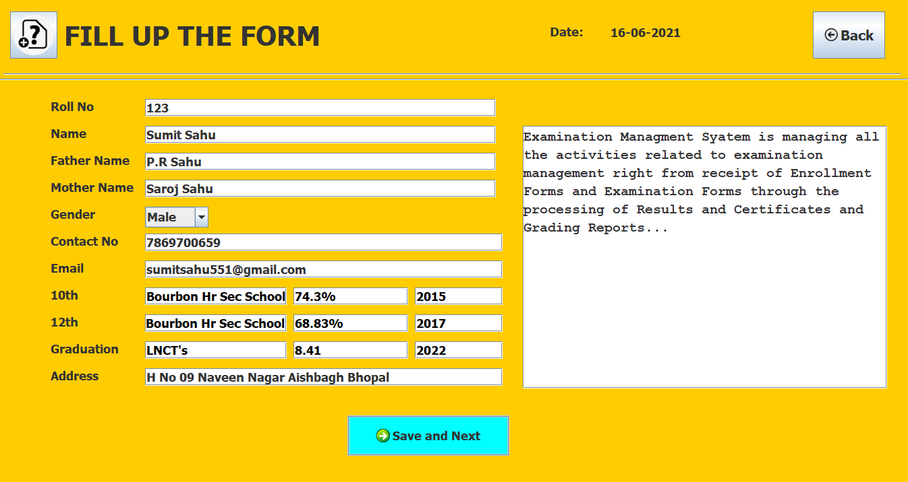

Exam Instruction:

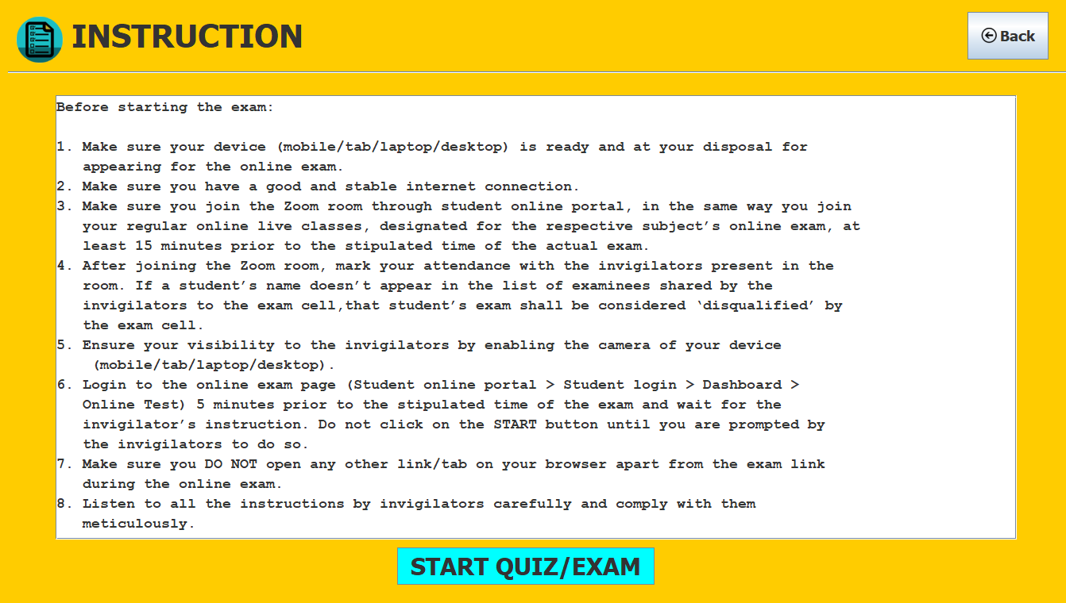

Quiz Start:

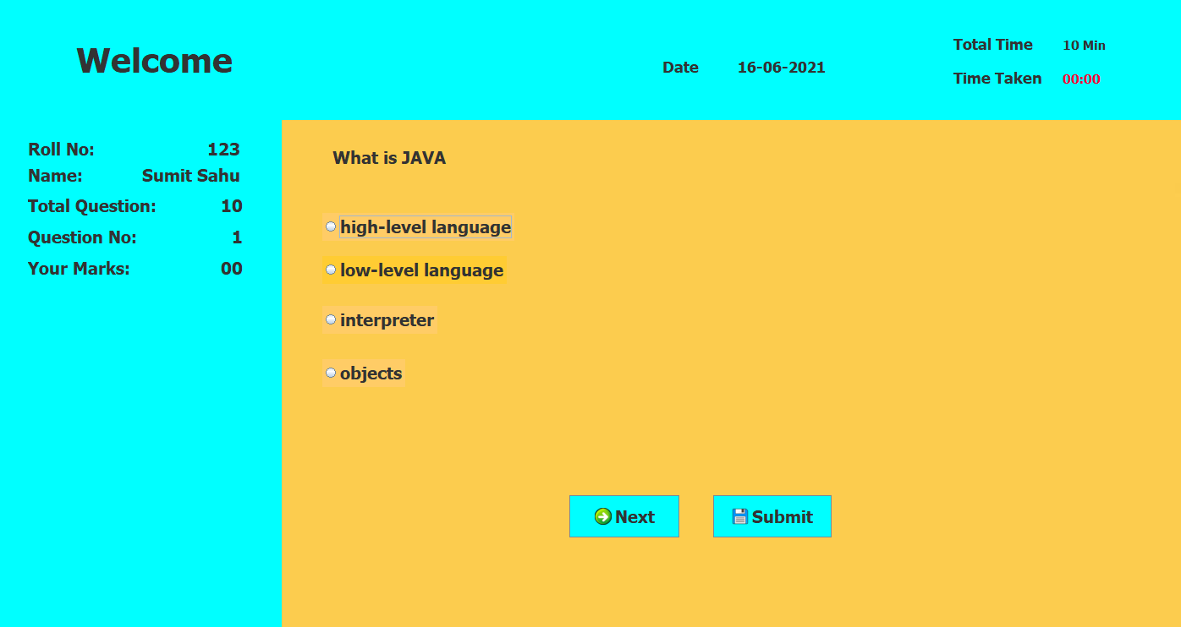

Quiz Submission:

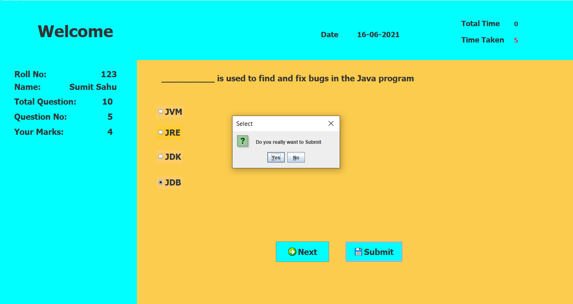

Student Marks:



CHAPTER 7 REFERENCES

- Patil, Pratekand Karl Moss, 2017, Java Database Programmingwith JDBC, Coriclis Group Books.
- Sierra, Kathyand Bert Bates, 2003, Head First Java, O’Reilly.
- Sarcar, Vaskaran, 2018, Java Design Patterns, Apress.
- http://www.javaworld.com/javaworld/jw-01-1998/jw-01-credentialreveiw.html
- http://jdbc-tutorial.com
- https://www.tutorialspoint.com/java
- http://www.javapoint.com/java-tutorial
- https://docs.oracle.com/javase/tutorial

